**Abstractive text summarization** is the task of generating a headline or a short summary consisting of a few sentences that captures the salient ideas of an article or a passage. We use the adjective ‘abstractive’ to denote a summary that is not a mere selection of a few existing passages or sentences extracted from the source, but a compressed paraphrasing of the main contents of the document, potentially using vocabulary unseen in the source document

* Analyzing sequences of input
* Understanding text
* Outputting sequences of output in form of summarizes

Hence the name of seq2seq , sequence of inputs to sequence of outputs , which is the main algorithm that is used here

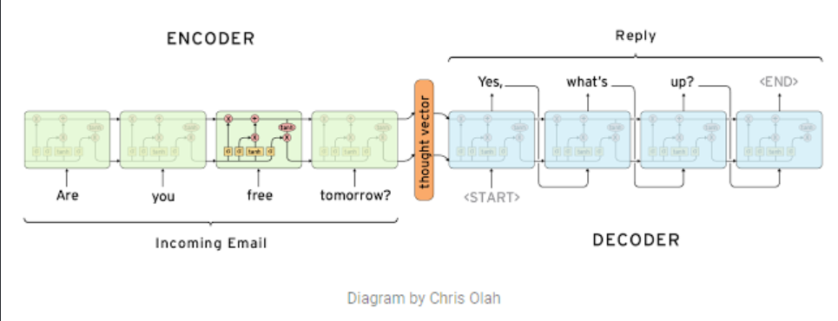

Implementations using a **seq2seq encoder(bidirectional LSTM ) decoder (with attention)**

**Models :**

* Basic encoder-decoder RNN that serves as our baseline and then propose several novel models for summarization, each addressing a specific weakness in the baseline.
* Encoder-Decoder RNN with Attention and Large Vocabulary Trick
* In summarization, one of the key challenges is to identify the key concepts and key entities
* capture additional linguistic features such as parts-of-speech tags, named-entity tags, and TF and IDF statistics of the words
* For continuous features such as TF and IDF, we convert them into categorical values by discretizing them into a fixed number of bins, and use one-hot representations to indicate the bin number they fall into. This allows us to map them into an embeddings matrix like any other tag-type
* Finally, for each word in the source document, we simply look-up its embeddings from all of its associated tags and concatenate them into a single long vector
* On the target side, we continue to use only word-based embeddings as the representation.